**Name: Ishaan Barde**

**Roll No: 116**

**CYBER FORENCIS PRACTICAL 1**

**S-TOOLS**

S-Tools or Steganography Tools: The tools to hide the secret messages in BMP, GIF, and WAV files. Learn more in: Digital Steganography Based on Genetic Algorithm

**STEGANOGRAPHY**

The word steganography is derived from the Greek words steganos (meaning hidden or covered*)* and the Greek root graph(meaning to write). Steganography can be used to conceal almost any type of digital content, including text, image, video or audio content; the data to be hidden can be hidden inside almost any other type of digital content. The content to be concealed through steganography -- called **hidden text** -- is often encrypted before being incorporated into the innocuous seeming cover text file or data stream. If not encrypted, the hidden text is commonly processed in some way in order to increase the difficulty of detecting the secret content.

**AIM : TO IMPLEMENT STEGANOGRAPHY**

1. **Download Stools**
2. **Drag and drop an image in the STools.**

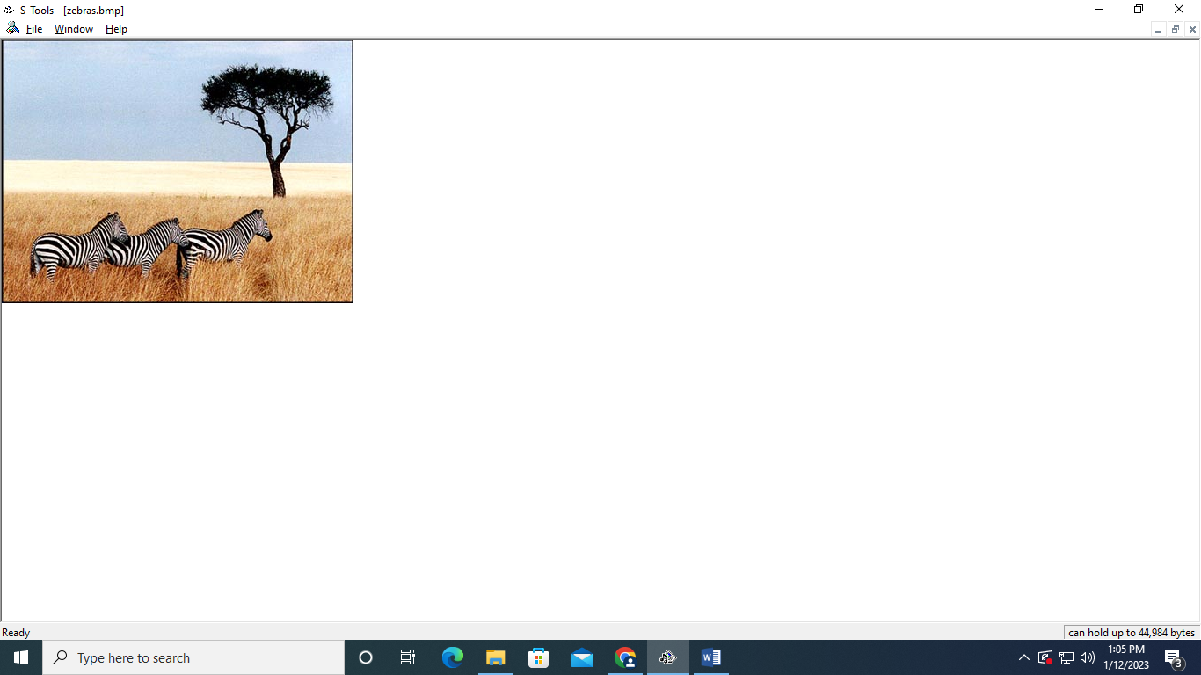

1. **Create a text file and drag and drop the text file on the image.**
2. **Add and verify passphrase**

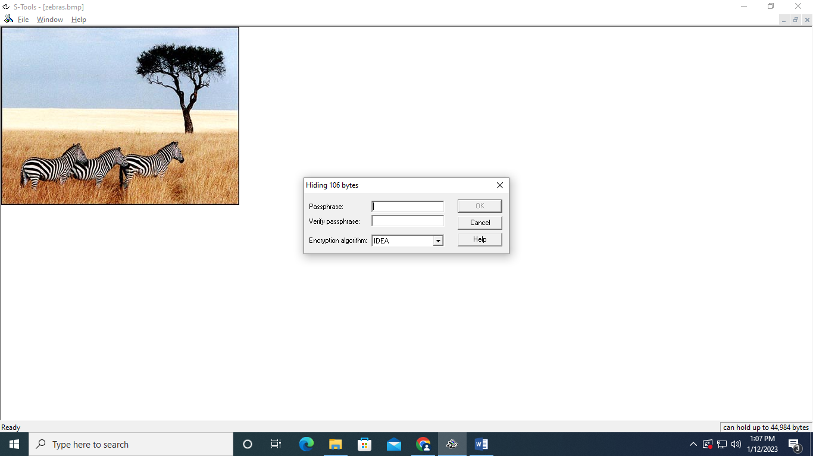

1. **You will now have a pop up of hidden data**

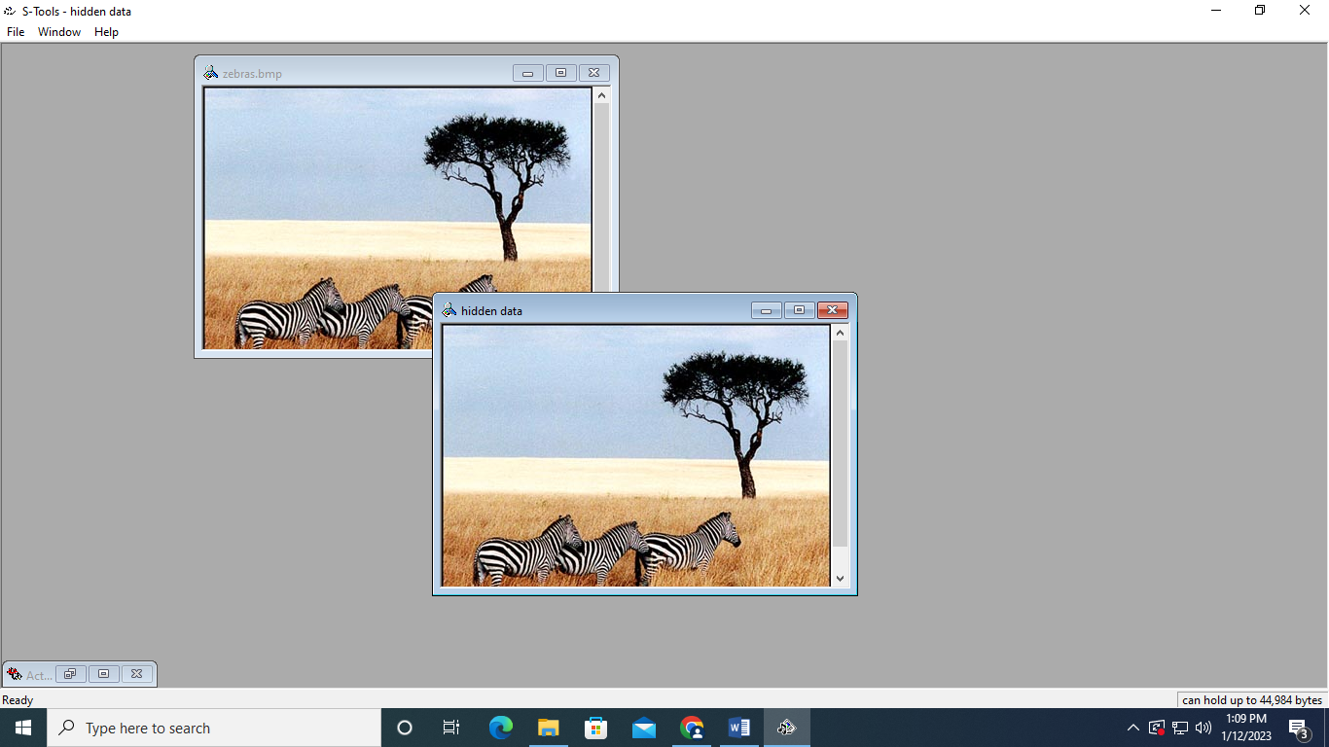

1. **Click on Reveal and Verify the passphrase to get access of the text file**

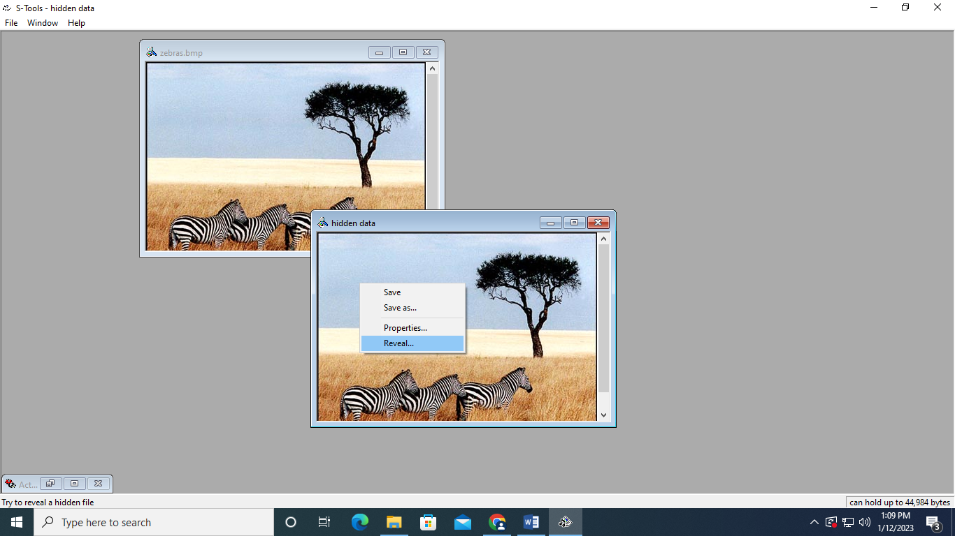

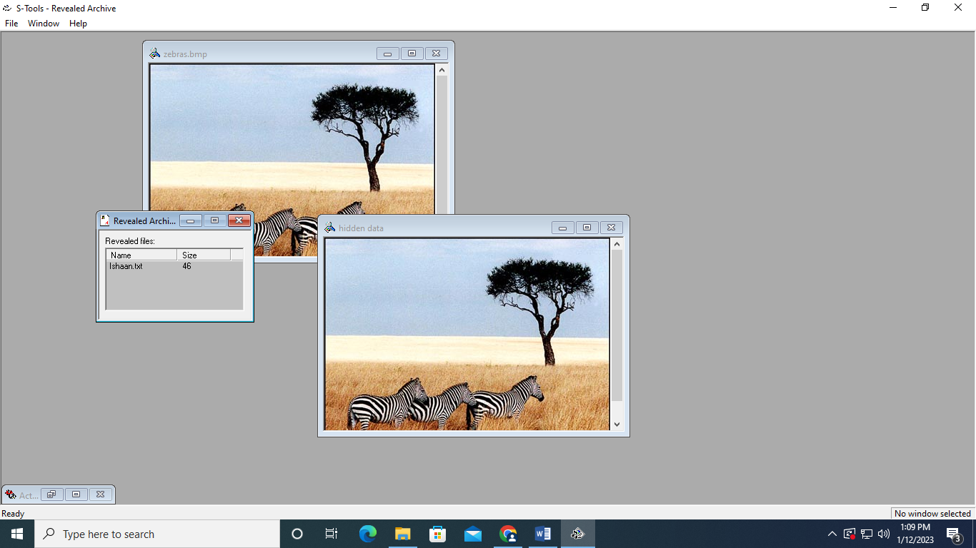

1. **Save the text file with a different name and check the contents**

